

Carbon Reduction Plan guidance

Notes for completion
Where an in-scope organisation has determined that the measure applies to the procurement, suppliers wishing to bid for that contract are required, as a condition of participation, to submit a CRP which details their organisational carbon footprint and confirms their commitment to achieving net zero by 2050.
CRPs are to be completed by the bidding supplier and must meet the reporting requirements set out in supporting guidance and include the supplier’s current carbon footprint and its commitment to reducing emissions to achieve net zero emissions by 2050.11
The CRP should be specific to the bidding entity, or, provided certain criteria are met, may cover the bidding entity and its parent organisation. In order to ensure the CRP remains relevant, a CRP covering the bidding entity and its parent organisation is only permissible where the detailed requirements of the CRP are met in full, as set out in the Technical Standard12 and Guidance, and all of the following criteria are met:
  - the bidding entity is wholly owned by the parent
  - the commitment to achieving net zero by 2050 for UK operations is set out in the CRP for the parent and is supported and adopted by the bidding entity, demonstrated by the inclusion in the CRP of a statement that this will apply to the bidding entity
  - the environmental measures set out are stated to be able to be applied by the bidding entity when performing the relevant contract
  - the CRP is published on the bidding entity’s website
Bidding entities must take steps to ensure they have their own CRP as soon as reasonably practicable and should note that the ability to rely on a parent organisation’s CRP may only be a temporary measure to satisfy this particular condition of participation.
The CRP should be updated regularly (at least annually) and published and clearly signposted on the supplier’s UK website. It should be approved by a director (or equivalent senior leadership) within the supplier’s organisation to demonstrate a clear commitment to emissions reduction at the highest level. Suppliers may wish to adopt the objectives of the CRP within their strategic plans.
A template for the CRP is set out below. Please complete and publish your CRP in accordance with the reporting standard published alongside this PPN.

11 ‘Bidding supplier’ or ‘bidding entity’ means, for the purpose of this guidance, the organisation with whom the Contracting Authority will enter into a contract if it is successful.
12 https://www.gov.uk/government/publications/ppn-006-guidance-on-taling-account-of-carbon-redcution-plans-adopting-and-applying-conditions-of-participation-html

Carbon Reduction Plan template
Supplier name
Niche Health and Social Care Consulting

Publication date
23rd June 2026

Commitment to achieving net zero
Niche Health and Social Care Consulting is committed to achieving net zero emissions by 2050

Baseline emissions footprint
Baseline emissions are a record of the greenhouse gases that have been produced in the past and were produced prior to the introduction of any strategies to reduce emissions.
Baseline emissions are the reference point against which emissions reduction can be measured.

Baseline year: 2023-24
Additional details relating to the baseline emissions calculations:
None
Baseline year emissions:
Emissions | Total (tCO2e)
Scope 1 | 0 – there are no direct emissions from company activities
Scope 2 | 1.221 tCO2e
Scope 3 (included sources) | Upstream transport 0  Waste 0  Business travel 3.894 tCO2e  Employee commuting 2.074 tCO2e  Downstream transport 0
Total emissions | 7.189 tCO2e

Current emissions reporting

Reporting year: 2025-26
Emissions | TOTAL (tCO2e)
Scope 1 | 0 – there are no direct emissions from company activities
Scope 2 | 0 – all electricity at the company’s offices is purchased on a fully renewable tariff
Scope 3 (included sources) | Upstream transport 0  Waste 0  Business travel 0.937 tCO2e  Employee commuting 2.807 tCO2e  Downstream transport 0
Total emissions | 3.744 tCO2e

Emissions reduction targets
In order to continue our progress to achieving net zero, we have adopted the following carbon reduction targets.
We projected in 2023-24 that carbon emissions would decrease over the next five years to 5.69 tCO2e by 2029. This was a planned reduction of 21%. We have since reduced emissions further, so that they are now 48% lower than in the baseline year.

Carbon reduction projects
Completed carbon reduction initiatives
The following environmental management measures and projects have been completed or implemented since the 2023-24 baseline:

We have converted our office electricity tariff to one using wholly renewable sources.

The carbon emission reduction achieved by these schemes equate to 1.221 tCO2e, a 17% reduction against the 2023-24 baseline and the measures will be in effect when performing the contract.
Future carbon reduction initiatives
In the future we plan to implement further measures such as:
- Continue to promote use of remote methods for client engagement wherever feasible, to reduce business travel
- Support staff to use public transport to access the office for commuting and/or to change to electric vehicles

Declaration and sign off
This Carbon Reduction Plan has been completed in accordance with PPN 006 and associated guidance and reporting standard for Carbon Reduction Plans.
Emissions have been reported and recorded in accordance with the published reporting standard for Carbon Reduction Plans and the GHG Reporting Protocol corporate standard13 and uses the appropriate government emission conversion factors for greenhouse gas company reporting.14
Scope 1 and Scope 2 emissions have been reported in accordance with SECR requirements (where required), and the required subset of Scope 3 emissions have been reported in accordance with the published reporting standard for Carbon Reduction Plans and the Corporate Value Chain (Scope 3) Standard.15
This Carbon Reduction Plan has been reviewed and signed off by the board of directors (or equivalent management body).

Signed on behalf of the supplier:

Date: 23rd June 2026

13 https://ghgprotocol.org/corporate-standard
14 www.gov.uk/government/collections/government-conversion-factors-for-company-reporting
15 https://ghgprotocol.org/standards/scope-3-standard

Annex – Guidance notes
- Please provide details of your organisation’s baseline emissions. If your organisation has not previously assessed or reported emissions, please state this and use your first reporting period as your baseline.
- Under Additional details relating to the baseline emissions calculations, please add details of your baseline emissions as required: for example, that it is a historic baseline which deviates from the requirements under this measure (e.g. no prior Scope 3 emissions reporting); that there had been no previous reporting; or that you have created a new baseline due to substantial organisational change or restructuring.
- Under the heading Emissions reduction targets, if your organisation already has emissions reduction targets, please give those targets. If your organisation had no previous emissions reduction commitment, or if this is your organisation’s first carbon footprint, please provide targets for your organisation. You may want to show progress against your targets in a graph, like the one show below:
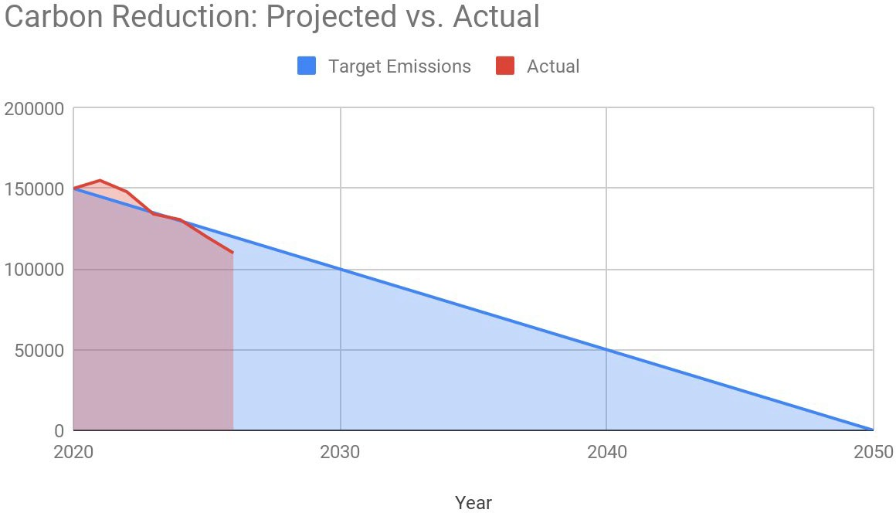


- Under the heading Completed carbon reduction initiatives, please provide brief details of some of your completed carbon reduction projects. This is for information only. This may include environmental management measures such as certification schemes like ISO14001 or PAS 2060, signing up to SBTI or specific measures you have taken such as: the adoption of LED/PIR lighting controls, changes to policy resulting in a reduction in company travel and flights or the electrification of the company fleet.
- Under the heading Future carbon reduction initiatives, please provide brief details of some of your likely/proposed future carbon reduction projects, if any. This is for information only.

